Planning Project: 3D Motion Planning

[1. Sebastian Introduction](https://classroom.udacity.com/nanodegrees/nd787/parts/300ffbd4-f9f0-4524-84fb-0b24d9d04cc3/modules/0c12632a-b59a-41c1-9694-2b3508f47ce7/lessons/5f628104-5857-4a3f-93f0-d8a53fe6a8fd/concepts/d1686165-428e-46a1-8f33-6a32ea4f5f09)

<https://www.youtube.com/watch?v=0ChnDlwpeBw>

[2. Project Intro](https://classroom.udacity.com/nanodegrees/nd787/parts/300ffbd4-f9f0-4524-84fb-0b24d9d04cc3/modules/0c12632a-b59a-41c1-9694-2b3508f47ce7/lessons/5f628104-5857-4a3f-93f0-d8a53fe6a8fd/concepts/450c6f40-68b3-40a2-851e-bc7e3467bf45)

<https://www.youtube.com/watch?v=hR__HI_Ocew>

[3. Workspace Intro](https://classroom.udacity.com/nanodegrees/nd787/parts/300ffbd4-f9f0-4524-84fb-0b24d9d04cc3/modules/0c12632a-b59a-41c1-9694-2b3508f47ce7/lessons/5f628104-5857-4a3f-93f0-d8a53fe6a8fd/concepts/ab09b378-f85f-49f4-8845-d59025dd8a8e)

# **Your Cloud Workspace**

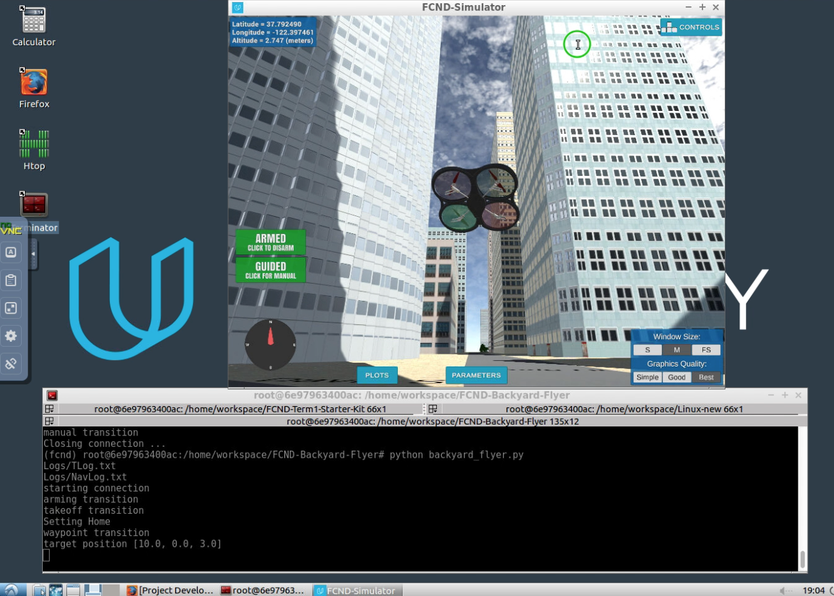

### **Udacity Cloud VM**

For this project, you will have the option to complete all of your work in a cloud-based GPU supported virtual machine (VM) right in the Udacity classroom! Graphics rendering in the VM seems to work best for internet connections faster than 10Mbps, so if you're on a good connection we highly recommend checking it out! You can test the speed of your connection by going to [fast.com](https://fast.com/). Then simply follow along with these instructions for getting started and you'll be up and running in no time with your new VM.

### **Work on your local machine**

If you would prefer to complete the project on your local machine, then you can skip ahead to the [instructions for local setup](https://classroom.udacity.com/nanodegrees/nd787/parts/5aa0a956-4418-4a41-846f-cb7ea63349b3/modules/0c12632a-b59a-41c1-9694-2b3508f47ce7/lessons/5f628104-5857-4a3f-93f0-d8a53fe6a8fd/project).

### **VM Setup Instructions**

The workspace VM is already setup with Python and the simulator for the 3D motion planning project. If you run into any problems with using the VM please file bugs, suggestions and grievances in the [waffle board](https://waffle.io/udacity/fcnd-issue-reports).

When you click "Next" at the bottom of this page to advance to the 3D Motion Planning project in the classroom you'll first see a popup asking if you want to enable GPU mode. Choose "yes".

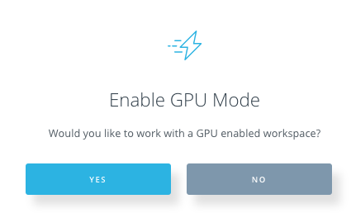

Next, your workspace will be configured and you'll land in a development environment that looks like this:

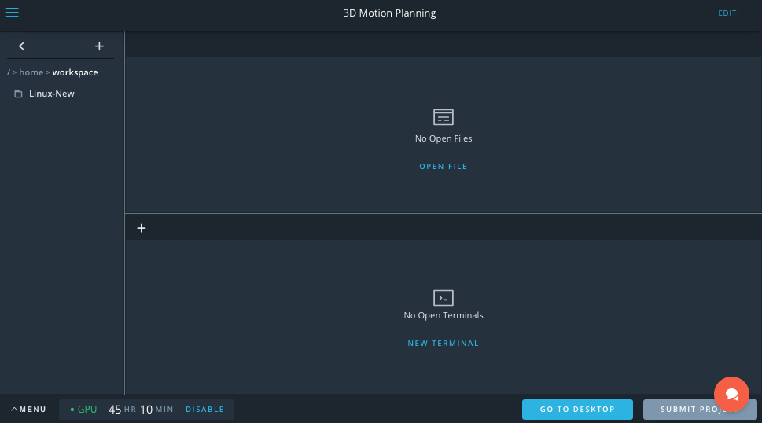

Click the button in the lower right that says "GO TO DESKTOP" and you'll launch another browser window, where you'll land at the desktop of your Linux VM that looks like this:

(**Note: the VM currently does not work with Safari, please use Chrome or other browser**)

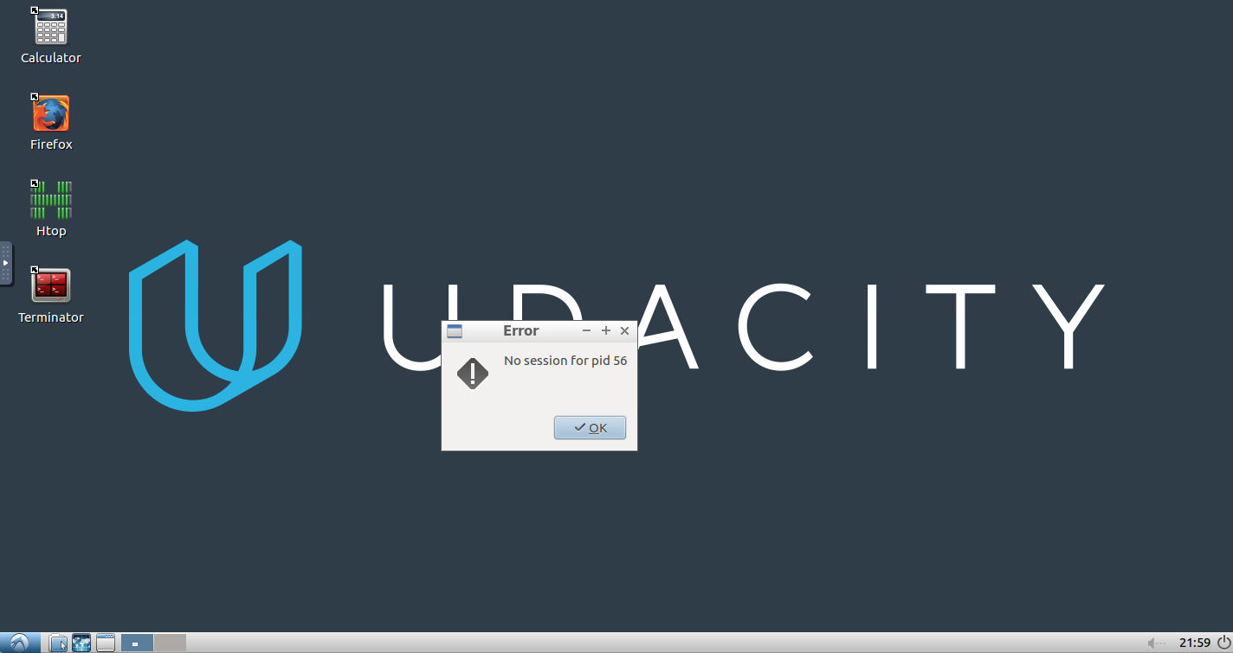

Don't worry about the error message, it's harmless, just click "OK". Next, double click on the "Terminator" icon on the desktop to open terminal. In the terminal you need to issue 3 commands:

cd /home/workspace/linux-64bit/  
./FCND-Sim_Linux_64-bit

**How to copy/paste:** At this point you may be wondering how to copy and paste between your local machine and the VM! It's a bit cumbersome unfortunately, but here's how it works:

* copy text on local machine
* open the side-bar menu at the left side of the VM desktop
* click the clipboard icon and paste text in there
* use ctrl-shift-v to paste into terminal (or ctrl-v to paste into Firefox browser)

Reverse these steps to copy/paste from the VM to your local machine.

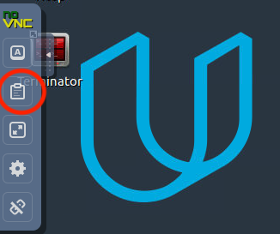

If the above method proves too cumbersome, as long as whatever you want to copy/paste is online, you can also just open up a browser (Firefox) in the VM and navigate to the material you want to copy / paste.

After issuing those commands, your simulator should launch! Now your desktop will look something like this:

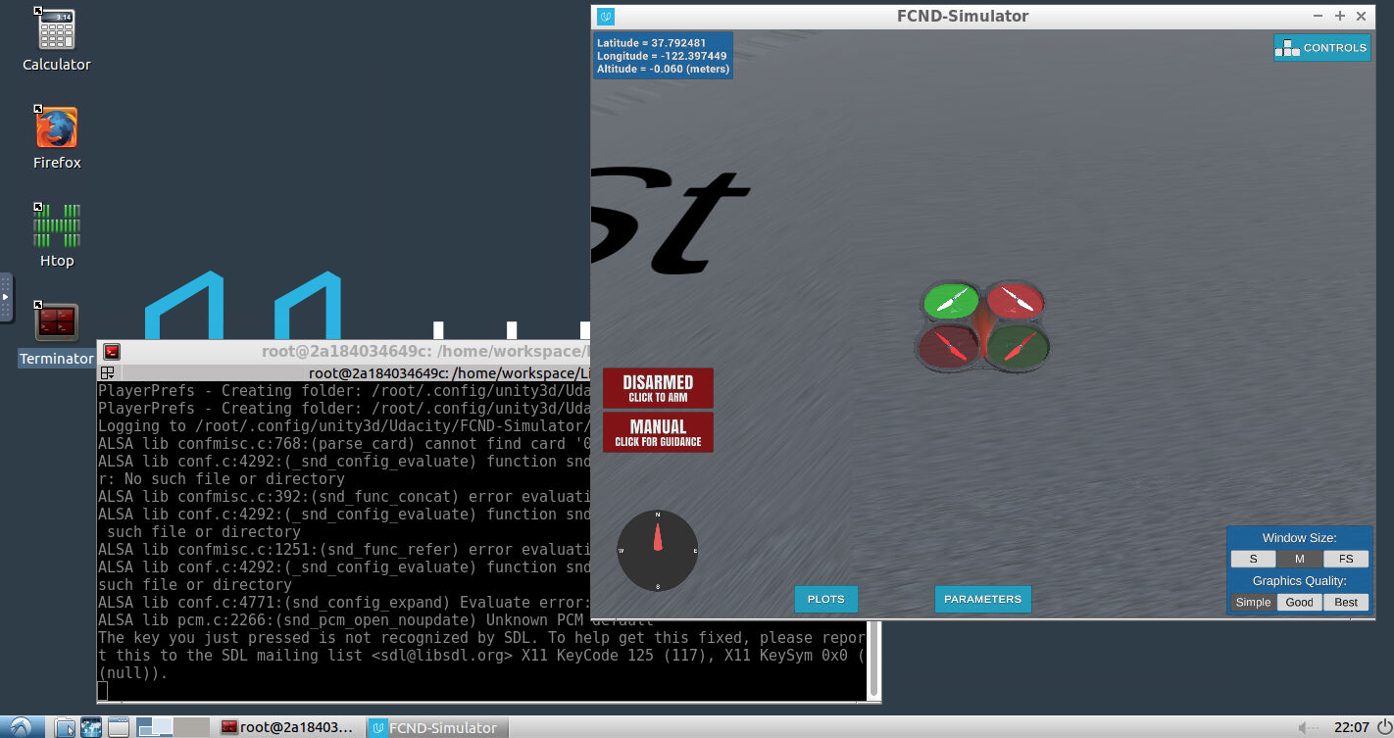

Click the button in the simulator that says "Click to Arm" and try some manual flying to explore this new environment. Click the "Controls" button in the upper righthand corner of the sim to get a reminder of keyboard and mouse functionality in manual mode.

If all of this works, you're ready to move on to testing autonomous flying and planning in this new environment. In a new terminal, run the following commands to clone the [project repository](https://github.com/udacity/FCND-Motion-Planning) into your /home/workspace directory:

cd /home/workspace  
git clone https://github.com/udacity/FCND-Motion-Planning

Next, activate the fcnd conda environment by typing source activate fcnd and then python at the prompt. You should now be running Python 3.6 in the fcnd conda environment.

source activate fcnd  
python

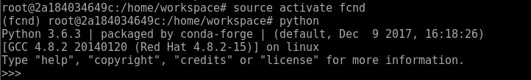

Explore the contents of the FCND-Motion-Planning folder you cloned. In there you'll find backyard_flyer_solution.py. To test if everything is working, change directories into the /home/workspace/FCND-Motion-Planning/ directory and try running the solution script. First, either launch your simulator as described above, or verify that your simulator is "DISARMED" and in "MANUAL" mode. Then launch the script like this:

cd /home/workspace/FCND-Motion-Planning/  
python backyard_flyer_solution.py

And with that you should be flying!



## **3D Motion Planning in Downtown San Francisco**

If that all works, well done! All that's left is to build your 3D Motion Planning solution. Check out the [README](https://github.com/udacity/FCND-Motion-Planning/blob/master/README.md) in the project repository for instructions on how to complete the project, and the [project rubric](https://review.udacity.com/#!/rubrics/1534/view)for details on what you need for a passing submission.

We have provided some starter code in motion_planning.py and planning_utils.py for you to get comfortable with how things will work for this project. First off, you can just run this code and see what happens. Hit shift-r (sometimes twice) to reset the simulator. Then run:

python motion_planning.py

You should see the quad takeoff and follow a zigzag series of waypoints for about 10 m then land.

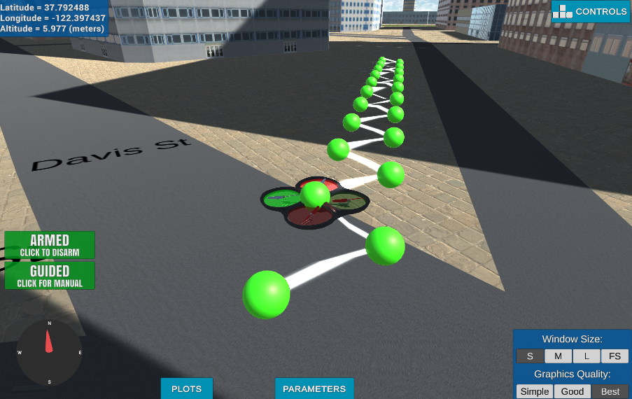

Next, take a look at the code in motion_planning.py as well as planning_utils.py to see what's going on in there. Use the gedit editor to view and edit files.

gedit motion_planning.py

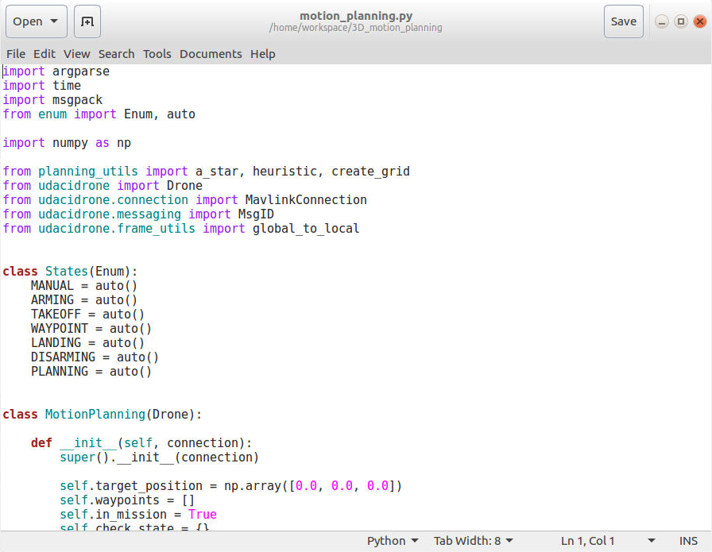

When you're ready to start building, have a look at the project [rubric](https://review.udacity.com/#!/rubrics/1534/view) to see what constitutes a passing submission!

### **Submitting your project through the workspace VM**

When you're satisfied with your solution, you can submit your project directly through the VM workspace. The way this works is that when you click "Submit Project" in the workspace IDE, everything in your /home/workspace folder will be zipped up and submitted. So the first step is to move everything you do not want to submit out of the /home/workspace directory.

The one thing you absolutely must remove from /home/workspace is the simulator (with the simulator the submission would be too big and fail to go through). You can temporarily move this to /opt while you submit your project.

cd /home/workspace  
mv FCND-Sim-Linux /opt

Next, move any other files or folders you do not intend to submit out of /home/workspace and then click the "Submit Project" button at the lower right in your workspace IDE (note: not in the VM desktop environment, but next to the "Go To Desktop" button on the IDE page).

When you have finished submitting, move any files you want to keep, including the simulator back into /home/workspace so they will be saved for your next visit to the VM.

[4. 3D Motion Planning](https://classroom.udacity.com/nanodegrees/nd787/parts/300ffbd4-f9f0-4524-84fb-0b24d9d04cc3/modules/0c12632a-b59a-41c1-9694-2b3508f47ce7/lessons/5f628104-5857-4a3f-93f0-d8a53fe6a8fd/concepts/ef2954ac-5cae-4689-b8e9-af20dedeba21)

<https://classroom.udacity.com/nanodegrees/nd787/parts/300ffbd4-f9f0-4524-84fb-0b24d9d04cc3/modules/0c12632a-b59a-41c1-9694-2b3508f47ce7/lessons/5f628104-5857-4a3f-93f0-d8a53fe6a8fd/concepts/ef2954ac-5cae-4689-b8e9-af20dedeba21>

[5. Project: 3D Motion Planning](https://classroom.udacity.com/nanodegrees/nd787/parts/300ffbd4-f9f0-4524-84fb-0b24d9d04cc3/modules/undefined/lessons/5f628104-5857-4a3f-93f0-d8a53fe6a8fd/project)

## Project Submission

## **Project completion steps:**

1. You can do this project in a classroom workspace virtual machine (VM)! The starter files linked below are already on the VM in the folder called /home/workspace/3D_motion_planning. **NOTE: if you have already checked out the VM be sure to "Reset data" to get the latest files!** If you choose to complete the project in the VM, follow the instructions [here](https://classroom.udacity.com/nanodegrees/nd787/parts/5aa0a956-4418-4a41-846f-cb7ea63349b3/modules/0c12632a-b59a-41c1-9694-2b3508f47ce7/lessons/5f628104-5857-4a3f-93f0-d8a53fe6a8fd/concepts/ab09b378-f85f-49f4-8845-d59025dd8a8e?contentVersion=1.0.0&contentLocale=en-us) to get setup.
2. If you're not going to work in the classroom VM, Download the Motion-Planning simulator for this project that's appropriate for your operating system from the [simulator releases respository](https://github.com/udacity/FCND-Simulator-Releases/releases)
3. Clone the [project repository](https://github.com/udacity/FCND-Motion-Planning)
4. git clone https://github.com/udacity/FCND-Motion-Planning
5. Run the backyard_flyer_solution.py script to fly a square flight pattern in this new environment as a test to see if everything is working as expected.
6. Follow along with the [README](https://github.com/udacity/FCND-Motion-Planning/blob/master/README.md) and the [Project Rubric](https://review.udacity.com/#!/rubrics/1534/view) to complete the steps to a passing submission of this project.

This project is a continuation of the Backyard Flyer project where you executed a simple square shaped flight path. In this project you will integrate the techniques that you have learned throughout the last several lessons to plan a path through an urban environment.

## **Evaluation**

Once you have completed your project, use the [Project Rubric](https://review.udacity.com/#!/rubrics/1534/view) to review the project. If you have covered all of the points in the rubric, then you are ready to submit! If you see room for improvement in **any**category in which you do not meet specifications, keep working!

## **Submission**

You may submit your project as a zip file or with a link to a GitHub repo. The submission must include

1. A detailed writeup of your results including how you addressed each rubric point and where it appears in your code.
2. The entire FCND-Motion-Planning folder with all of your code as scripts and / or notebooks.

When you are ready to submit the project. Click on the "Submit Project" button and follow the instructions to submit!

## **Feedback**

Please fill out the [3D Motion Planning Project Feedback Form](https://goo.gl/forms/Biyb3q2AXVIxXqf62) after you have completed the project.

## **Share Your Project**

Have something fun to share? Did your drone fly safely from A to B or fly in upward circles around the same building? Perhaps your drone thought it was a frog and jumped from building top to building top? Either way, we love to see any and all of your creations!

What you’ve accomplished is no small feat. Give yourself a pat on the back and some well-deserved recognition by sharing your amazing project with your network.

Create a gif or youtube video of your project implementation in the simulator and share with us in the [Flying Car Slack Community](https://udacity-flying-car.slack.com/messages/C77GCKZ8U) and on social media using the links below!

Make sure to use **@Udacity**, **#flyingcarnd**, **#3dplanning**, and **#madewithudacity** in your posts!